Option D
This example is based on a topic of multiplying and dividing whole numbers.
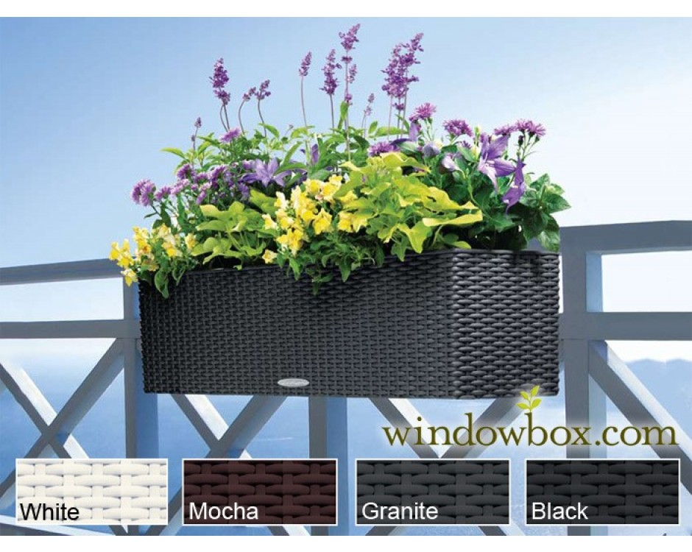

Description: Build something that requires you to use addition or subtraction of fractions/mixed numbers. This project should be brought to school in a shoe box. It also needs to include a one page write up of the relationship to what we are learning.
Please note:
- I would actually build this
- I would bring this to school in a shoebox
I would write my paper on things like:
- it being twice as wide as it is tall
- how I found the width was to take the height times two
- how this is something I could use in real life by building the flower box for a window ledge

