**Math & Social Studies Project**

**Fact:** The Bald Eagle was chosen as the National Bird and became the central figure in the official National Seal in 1782. Adult female bald eagles grow to be larger than adult male bald eagles. The average female has a body length of about 36 inches and a wingspan of about 84 inches. The average male has a body length of about 32 inches and a wingspan of about 78 inches.

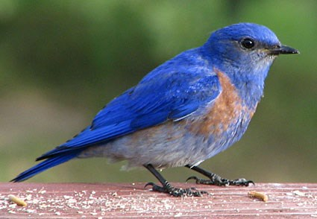

**Directions:** Research our state bird to find the length and wingspan for both the female and the male. Determine the ratio of wingspan to body length for both. Then find the ratio of your “wingspan” to your height. Who has the greater ratio?

|  |  |  |  |
| --- | --- | --- | --- |
| **Blue Bird** | **Length** | **Wingspan** | **Ratio  (fraction in simplest form)** |
| **Female** |  |  |  |
| **Male** |  |  |  |

|  |  |  |  |
| --- | --- | --- | --- |
| **Human** | **Height** | **Wingspan** | **Ratio** |
| **You** |  |  |  |

Who has the greater ratio? Circle one**:   
Female Blue Bird Male Blue Bird You**

**Math & Social Studies Project**

**Fact:** The Bald Eagle was chosen as the National Bird and became the central figure in the official National Seal in 1782. Adult female bald eagles grow to be larger than adult male bald eagles. The average female has a body length of about 36 inches and a wingspan of about 84 inches. The average male has a body length of about 32 inches and a wingspan of about 78 inches.



**Directions:** Research our state bird to find the length and wingspan for both the female and the male. Determine the ratio of wingspan to body length for both. Then find the ratio of your “wingspan” to your height. Who has the greater ratio?

|  |  |  |  |
| --- | --- | --- | --- |
| **Blue Bird** | **Length** | **Wingspan** | **Ratio  (fraction in simplest form)** |
| **Female** |  |  |  |
| **Male** |  |  |  |

|  |  |  |  |
| --- | --- | --- | --- |
| **Human** | **Height** | **Wingspan** | **Ratio** |
| **You** |  |  |  |

Who has the greater ratio? Circle one**:   
Female Blue Bird Male Blue Bird You**