**Math & Science Project**

**Fact:** The surface area of Earth is about 500,000,000 kilometers squared. North America is the third largest continent with an area of about 22,944,026 kilometers squared. That’s about 5% of the Earth’s surface area.

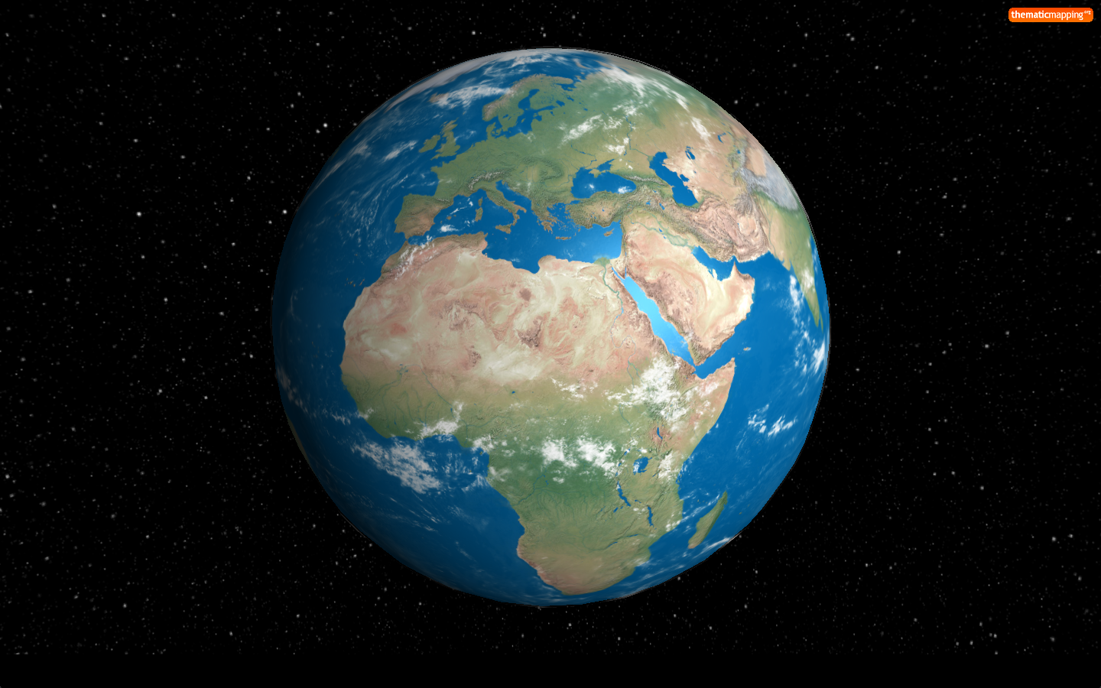

**Directions:** Research the following continents areas. Use exact number for the area. Find the percent compared to the Earth’s surface area. Round the decimal to the nearest thousandth and the percent to the nearest whole number.

|  |  |  |  |
| --- | --- | --- | --- |
| **Continents** | **Area** | **Decimal** | **Percent** |
| **Asia** |  |  |  |
| **Africa** |  |  |  |
| **North America** | 22,944,026 | 0.046 | 5 |
| **South America** |  |  |  |
| **Antarctica** |  |  |  |
| **Europe** |  |  |  |
| **Oceania (Australia)** |  |  |  |

**Math & Science Project**

**Fact:** The surface area of Earth is about 500,000,000 kilometers squared. North America is the third largest continent with an area of about 22,944,026 kilometers squared. That’s about 5% of the Earth’s surface area.



**Directions:** Research the following continents areas. Use exact number for the area. Find the percent compared to the Earth’s surface area. Round the decimal to the nearest thousandth and the percent to the nearest whole number.

|  |  |  |  |
| --- | --- | --- | --- |
| **Continents** | **Area** | **Decimal** | **Percent** |
| **Asia** |  |  |  |
| **Africa** |  |  |  |
| **North America** | 22,944,026 | 0.046 | 5 |
| **South America** |  |  |  |
| **Antarctica** |  |  |  |
| **Europe** |  |  |  |
| **Oceania (Australia)** |  |  |  |